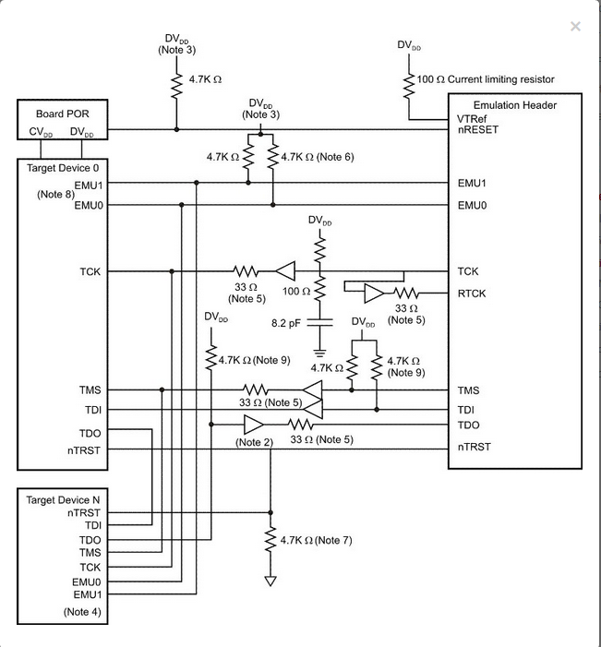

**Notes:**

1. If your devices have an RTCK pin, see [Multi-device Adaptive Clocking](http://software-dl.ti.com/ccs/esd/documents/xdsdebugprobes/emu_xds_target_connection_guide.html#multi-device-adaptive-clocking).
2. If the final device on the scan chain is within 6 inches of the emulation header, then the TDO buffer may not be required.
3. DVDD is the JTAG/EMU pin IO voltage reference.
4. This configuration assumes that the devices are within 6 inches of each other. Additional buffering may be required on TDO and TDI between devices if the routing distance is greater than 6 inches.
5. The 33Ω series termination resistors in this diagram were selected based on using a [SN74VC1G32](http://www.ti.com/product/sn74lvc1g32) (or gate) as a buffer. You should size the series termination resistor based on the output impedance of your buffer.
6. Pull-ups on EMU0 and EMU1 are required. See [EMU pin Considerations](http://software-dl.ti.com/ccs/esd/documents/xdsdebugprobes/emu_xds_target_connection_guide.html#emu-pin-considerations) for additional details.
7. A pull-down on TRST is required. See [JTAG and nTRST Special Considerations](http://software-dl.ti.com/ccs/esd/documents/xdsdebugprobes/emu_xds_target_connection_guide.html#jtag-and-ntrst-special-considerations) for additional details.
8. If your device contains more than two EMU pins, then it's likely that it supports the export of core trace or system trace (or both). These are high-speed features that impose additional target board requirements (for details, see [Emulation and Trace Headers TRM](http://www.ti.com/lit/ug/spru655i/spru655i.pdf)).
9. Pull-up resistors are recommended on all buffer inputs to eliminate the possibility of the buffer output oscillating when an XDS cable is not connected.

Generally TCK, TMS, TDI and TDO should be buffered to provide adequate signal drive between the processor array and the XDS. It is recommended that TCK, TMS and TDI be buffered through the same physical package for better control of signal skew effects. If the last device on the scan chain is less than 6 inches from the XDS header then the TDO buffer is not necessary.

Input buffers on TMS, TDI, and TCK should have pull-up resistors connected to DVDD I/O voltage reference to hold these signals at a proper value when the XDS target cable is not connected. A resistor value of 4.7kΩ or greater is suggested.

In cases where your design has just a few devices (not more than 3) on a serial scan chain and the JTAG signal (TCK, TMS, TDO and TDI) routing is less than 6 inches, buffering the JTAG signals may not be necessary. If you decide your design does not require buffers, the series termination resistors recommended in [Single Device Non-buffered Configuration](http://software-dl.ti.com/ccs/esd/documents/xdsdebugprobes/emu_xds_target_connection_guide.html#single-device-non-buffered-configuration) may still be necessary.

If your design utilizes more than three devices, it is recommended you simulate, at a minimum, the TCK and TMS paths. TI does not recommend placing more than 30 devices on a single JTAG scan chain.